Ex.no:4b | EXPLORATORY DATA ANALYSIS (EDA) – DATA INSPECTION, FILTERING, STATISTICAL ANALYSIS AND CORRELATION

Aim:
To perform data inspection, filtering, sorting, grouping, aggregation, descriptive statistical analysis, and correlation analysis on the Chess Games Dataset using Pandas, and to visualize the analytical results using Matplotlib.
Algorithm:
Algorithm 1: Dataset Inspection
Import the Chess Games dataset.
Display the complete dataset.
Display the first five records of the dataset.
Check the dimensions of the dataset.
Display the data types of the attributes.
Generate a statistical summary of the numerical attributes.
Algorithm 2: Filtering Games Won by White
Select the winner attribute.
Specify the filtering condition as winner == "White".
Apply the condition to the dataset.
Display the filtered games won by White.
Algorithm 3: Filtering Rated Games
Select the rated attribute.
Specify the filtering condition as rated == "True".
Apply the condition to the dataset.
Display the filtered rated games.
Algorithm 4: Sorting Data
Select the turns attribute.
Apply the sort_values() function.
Specify descending order.
Display the sorted records.
Algorithm 5: Statistical Analysis
Select the turns attribute.
Calculate the mean number of turns.
Calculate the median number of turns.
Calculate the mode of the number of turns.
Calculate the standard deviation.
Display the calculated statistical measures.
Algorithm 6: Grouping and Aggregation
Select the categorical attribute winner.
Apply the groupby() function.
Select the turns attribute.
Calculate the average number of turns for each winner.
Sort the grouped results in descending order.
Display the grouped results.
Algorithm 7: Visualization
Select the average number of turns grouped by winner.
Create a bar chart using Matplotlib.
Add the title and y-axis label.
Display the graph.

Algorithm 8: Correlation Analysis
Select the numerical attributes turns, white_rating, black_rating, opening_ply, and Rating_Difference.
Apply the corr() function.
Generate the correlation matrix.
Display the correlation coefficients between the selected attributes.

CODE:
# Import libraries

import pandas as pd
import matplotlib.pyplot as plt
import seaborn as sns

# Read dataset

df = pd.read_csv("games.csv")

# Display dataset

print(df)

# Display first five records

print(df.head())

# Display shape

print(df.shape)

# Display data types

print(df.dtypes)

# Display statistical summary

print(df.describe())

# Display games won by White

white_wins = df[df["winner"] == "White"]

print(white_wins.head())

# Display rated games

rated_games = df[df["rated"] == True]

print(rated_games.head())

# Sort by number of turns

sorted_df = df.sort_values(
by="turns",
ascending=False
)

print(sorted_df.head())

# Calculate mean number of turns

print(
"Mean :",
df["turns"].mean()
)

# Calculate median number of turns

print(
"Median :",
df["turns"].median()
)
# Calculate mode

print("Mode :")

print(
df["turns"].mode()
)
# Calculate standard deviation

print(
"Standard Deviation :",
df["turns"].std()
)
# Calculate average number of turns by winner

winner_avg = df.groupby("winner")[
"turns"
].mean()

print(
winner_avg.sort_values(
ascending=False
)
)

# Plot average number of turns by winner

winner_avg.sort_values(
ascending=False
).plot(
kind="bar"
)

plt.title(
"Average Number of Turns by Winner"
)

plt.ylabel(
"Average Number of Turns"
)

plt.xlabel(
"Winner"
)

plt.show()

# Calculate correlation

corr = df[
[
"turns",
"white_rating",
"black_rating",
"opening_ply"
]
].corr()
print(corr)

Output:
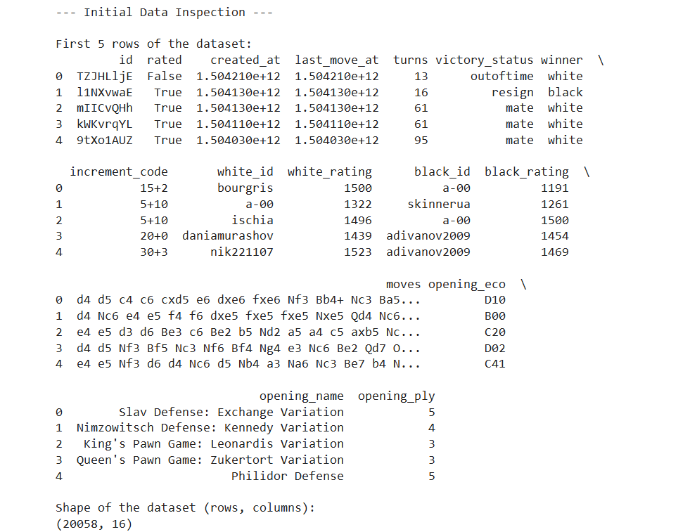
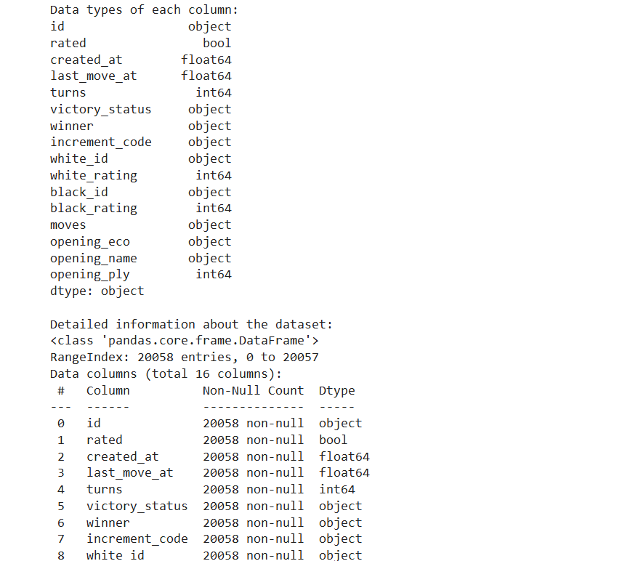
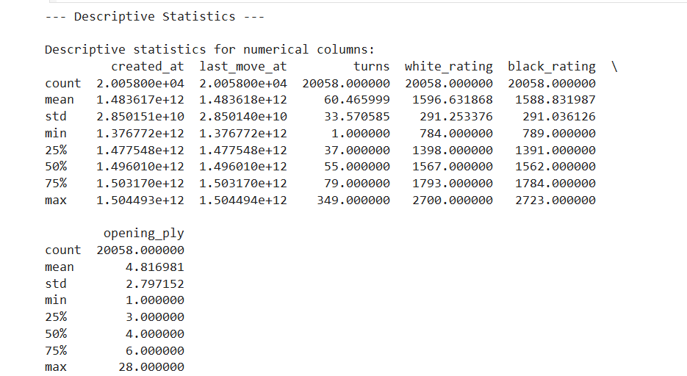

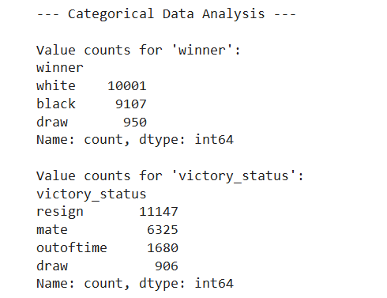
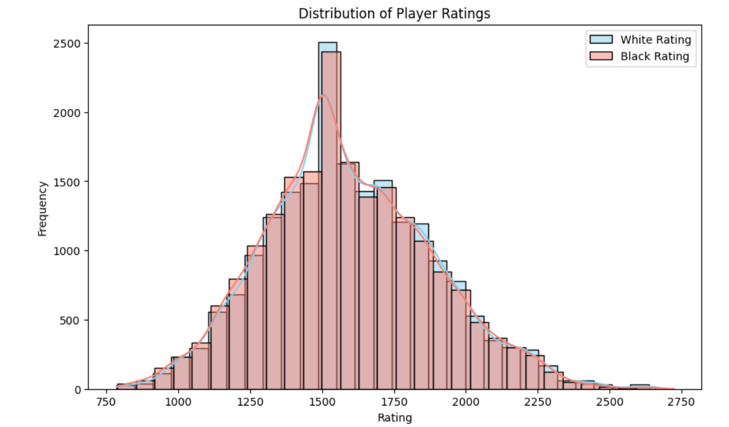

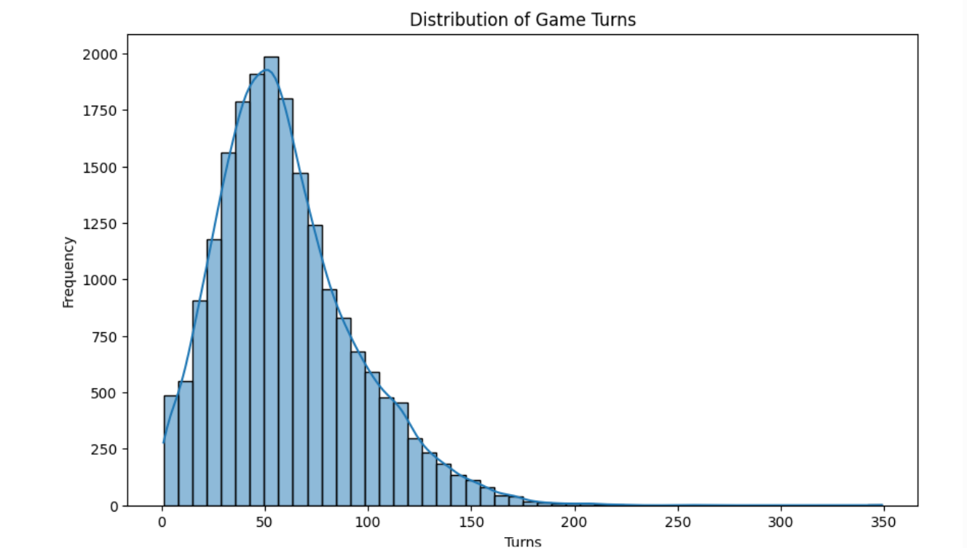

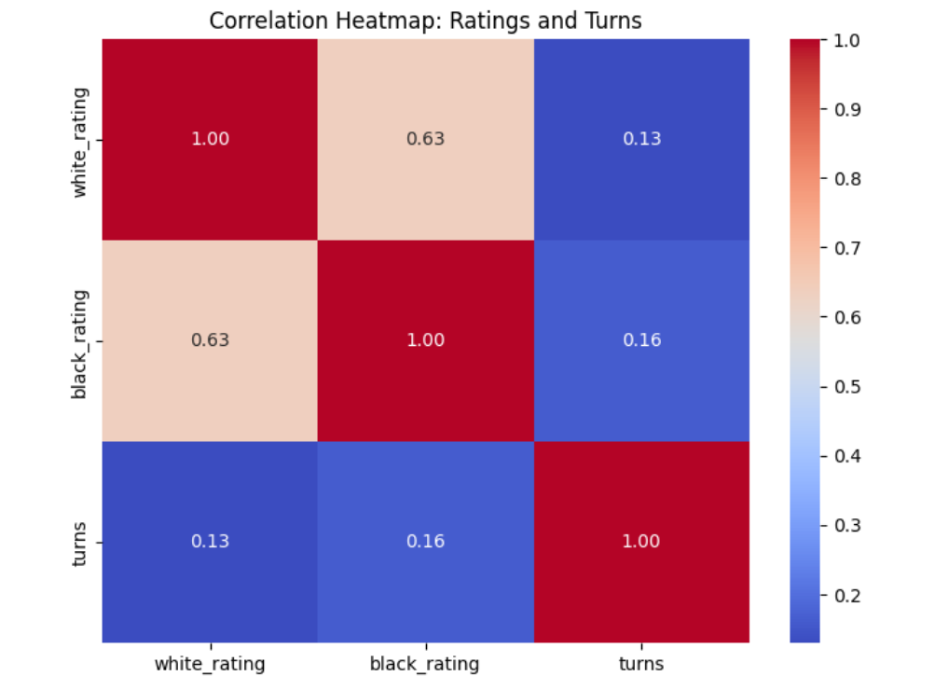
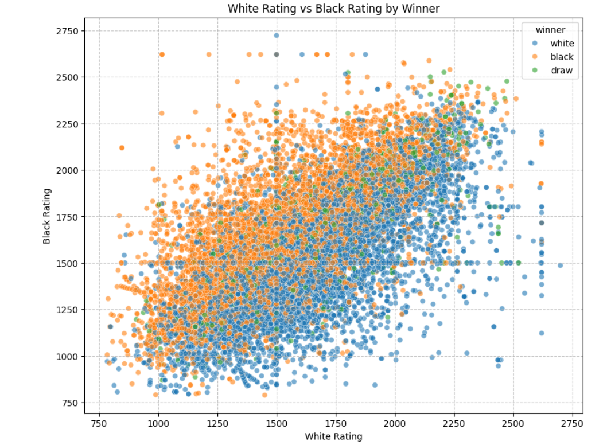
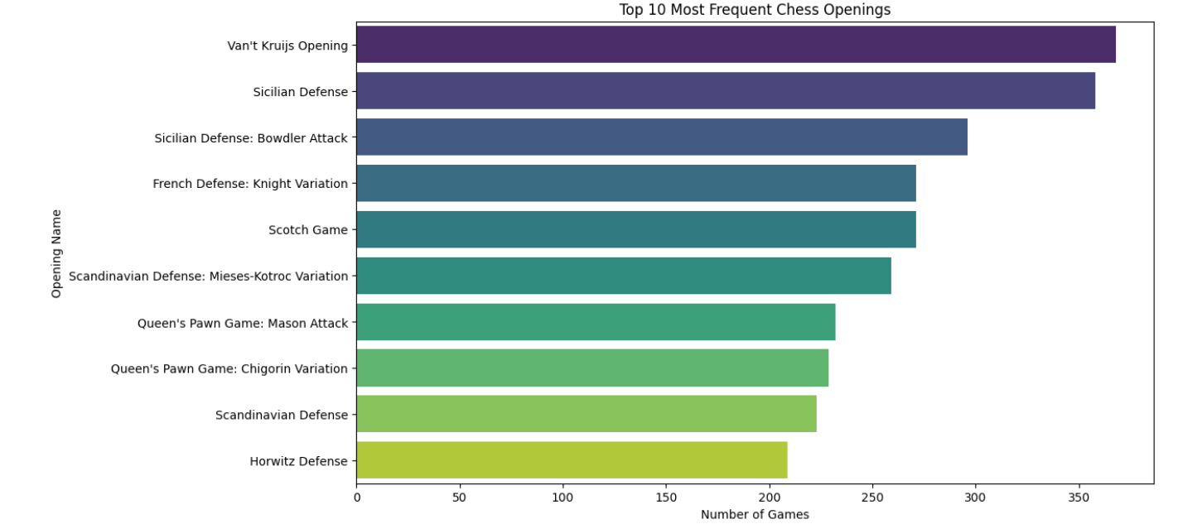

Result:

